Allied Land and Timber Co., Inc.
P.O. Box 227
Americus, Ga. 31709 1-800 224 9939 www.alliedlandga.com
John T. Conger, III Associate Broker 912 584 1142 Phone/Fax
2878 Evergreen Road 912 614 4646 Cell Phone
Waycross, Georgia 31503 jtc3@gate.net e-mail
LAND FOR SALE
78.368 Acres +/-
Brantley County, Georgia
Brantley 78

LOCATION: This tract is located in LL 156 LD 2nd of Brantley County, Georgia. Access is from County Grade #102, aka Seed Orchard Road, which is the northern boundary of the property. Nahunta, the county seat of Brantley County, is four miles to the south. The tract is approximately 60 miles north of Jacksonville, Florida and 35 miles west of Brunswick, Georgia and Interstate 95.

TRACT DESCRIPTION: There are approximately 30 acres of planted pines planted in approximately year 1999-2000 planting season. The timber value is estimated to be $40,000. There is approximately 10 acres of open pasture. The balance of 31 acres is in merchantable hardwood area. The tract has great deer and turkey hunting. Think 1031 exchange or investment. Possible Blue Berry farm.

TERMS: Cash to seller at closing.

PRICE: $124,650 $1,590 per acre
NOTE: Buyer is urged to get their own timber value, neither Seller nor Allied guarantee any timber values.

For more information contact:

John Conger
2878 Evergreen Road
Waycross, GA 31503
912 614 4646 Mobile
www.alliedlandga.com
Bobby Taylor,
Allied Land & Timber Co., Inc
P.O. Box 227
Americus, GA 31709
1 800 224 9939

Allied Land and Timber Co., Inc.
P.O. Box 227
Americus, Ga. 31709 1-800 224 9939 www.alliedlandga.com

AERIAL PHOTO BRANTLEY 78 (For location only)
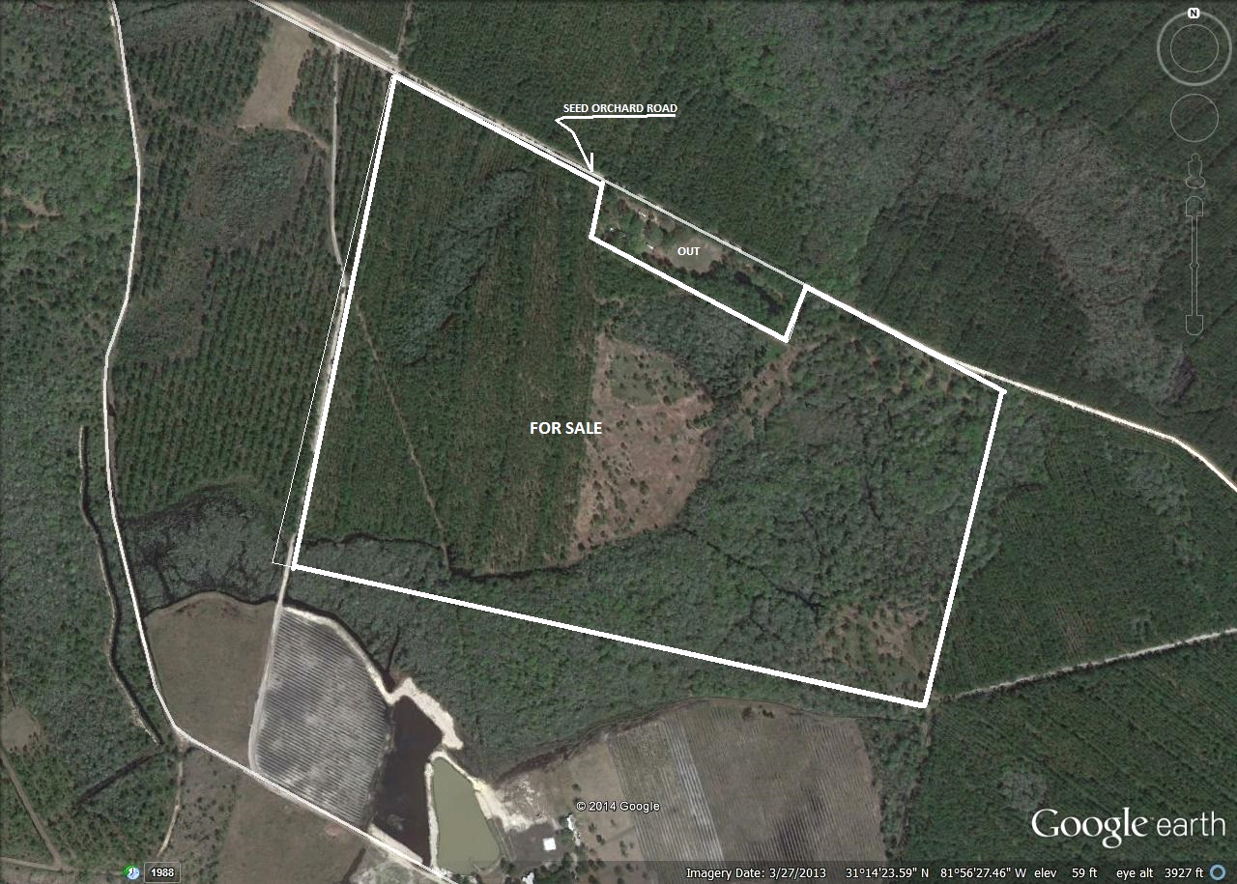

Allied Land and Timber Co., Inc.
P.O. Box 227
Americus, Ga. 31709 1-800 224 9939 www.alliedlandga.com

Location Map Brantley 78

